To mitigate the effect of friction, wear and heat generation, bearings are lubricated.

With gradual application of torque, the impact/contact forces vary through the meshing cycle and thus impact forces are often due to the crushing stiffness of the teeth. Variable load change the physics of the lubricated film so called regime of lubrication.

The lubricated contacts generally fall into a number of regimes of lubrication. These are:

1. **Hydrodynamic** (a lubricant film completely separates the contacting surfaces, also at light load: several Newtons at most). Hence, there is no deflections $∆$ or $δ$. The pressure is in region of MPa.
2. **Elastohydrodynamic** a lubricant film completely separates the contacting surfaces at medium to heavy load). Hence, there is usually deflection $δ$. There may even be some bending deflection $∆$ at heavier loads. The pressure is in the region of GPa
3. **Mixed** (an interrupted oil film separates the surfaces, i.e. some asperities of rough surfaces interact as well). This can occur at any load.
4. **Boundary** (there is negligible oil film and the surfaces directly interact). This is a dry contact. At medium to high loads we can assume Hertzian conditions (assumptions were described before).

**Contact Stiffness**

In general, the load carried by the elastic solids (e.g. the roller and races) is also carried by the lubricant film in the gap between them.

At different loads different regimes of lubrication are dominant. Under each of these, the equivalent stiffness can be simplified as:

1. If **Low** Load **Hydrodynamic** is present (light load): The lubricant film stiffness is much smaller than the Hertzian Stiffness. So, in a system of stiffnesses in series, lubricant stiffness is dominant and the solid stiffness can be neglected. **So, dynamics is governed by 𝑘𝑜.**
$$\frac{1}{k_{equivalent}}=\frac{1}{k}+\frac{1}{ko}$$

2. If **High** Load **Elastohydrodynamic** is present (high load): Lubricant film becomes several orders higher than the Hertzian contact stiffness. Hence, in a system of stiffnesses in series, lubricant stiffness can be neglected. So, **Lubricant has no effect on dynamics (but friction).**

$$\frac{1}{k_{equivalent}}=\frac{1}{k}+\frac{1}{ko}$$

**Film Formation Mechanisms**

A lubricant film is formed when two contiguous bodies undergo relative motion, with a lubricant presence between them. The two bodies make a wedge and the lubricant is entrained into the contact (see figure below). Notice that the two rollers are replaced by an equivalent roller near a flat plane.

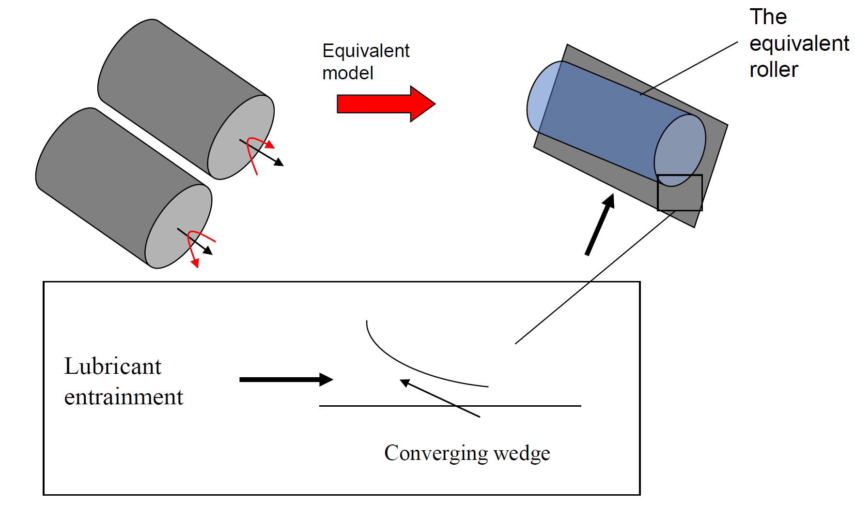

A pair of cylinders in contact form a long and narrow rectangular footprint (line contact). The long elliptical contact formed between roller and race at any instant of time can be approximated by this narrow rectangular footprint. Therefore, at any instant of time the contact of roller and race may be considered as a pair of cylinders in contact. We model this as an equivalent cylinder near a flat plane (as already described, with this equivalent cylinder, having a radius as shown by $r_{zx}$).

The relationship between the contact/impact force and lubricant film thickness, h and its rate of change with time (squeeze velocity) depends on the regime of lubrication.

**Hydrodynamic Force**